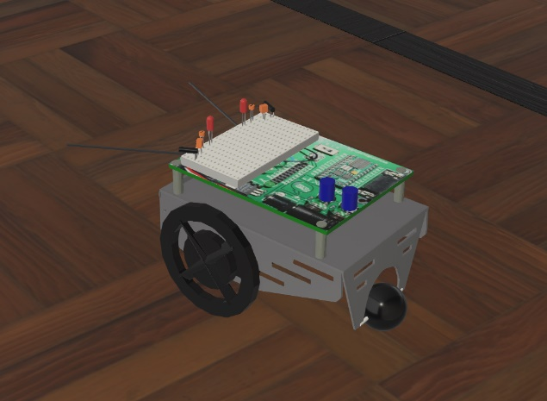***Context***:

An object sits at position (x1, y1), the values are arbitrary. For our project we will be required to move the object to a different position at (x2, y2). We aren’t making use of a multidirectional robot which can move in any direction at any time, however, an unidirectional robot which can rotate.

Figure : the robot

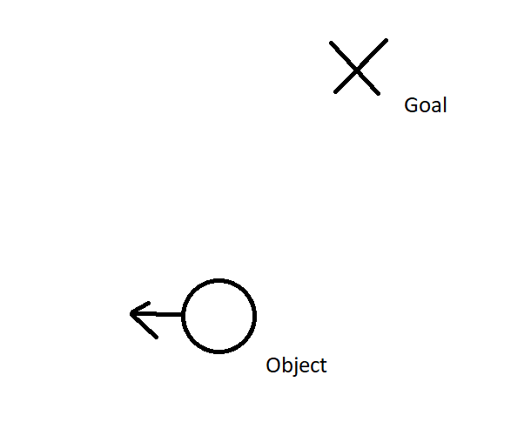***The situation***:

The object is not facing the goal which will cause the object to have difficulty moving towards the goal.

Figure : the situation

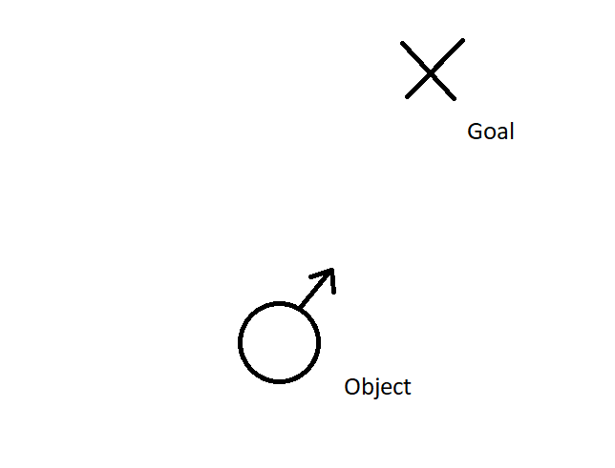***The achievement***:

Orienting the object in the right direction by using math so that it’ll be easier to direct the object to the right position.

Figure : the achievement

***How we’re going to achieve this***:

1. Examine the coordinates of the goal and object
2. Calculate distance from object to goal in arbitrary unit.
3. Draw a from

https://www.cuemath.com/calculators/central-angle-calculator/